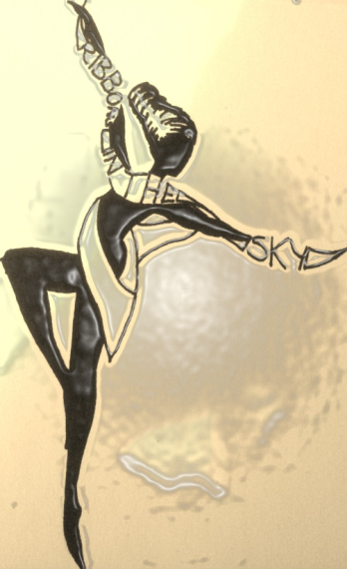
Ribbon in the Sky Arts does ……

Halloween!!!

Fun-filled Theatre Activity sessions for children aged 3-12 years at Bradley Village Hall this Autumn Half- Term…………….
October 29th 9:30-11:30- ‘Little things that go bump!!’ (Ages 3-6)
Favourite stories such as ‘Room on the Broom’, ‘Whinnie the Witch’ and the magic spells and mayhem of Halloween inspire our fun-filled creative morning of drama, dance, music, circus, adventure, story-telling, crafts and face paints. Ps. Children will definitely not be scared… (but may become scary if they want to!)

October 29th 12-2:30- ‘Make A Spooky Play in a Day’: (Ages 7-12) ENDS WITH AN EXCLUSIVE PRESENTATION FROM THE PARTICIPANTS AT 2:30 FOR FRIENDS AND FAMILY.
For brave children who love Harry Potter, stories with vampires, giants, skeletons, haunted castles, and then acting them out- this is a brilliant fun, energetic and challenging session to produce a unique piece of theatre to be proud of, in a very limited amount of time! No previous experience necessary- just plenty of have-a-go spirit! (The informal performance at the end will last around 15 minutes.)

£10 per session. Multi-sibling discounts are available for all sessions- please contact us directly for details!
www.facebook.com/ribbonintheskyarts.
Contact Kat Osborn on 01535 635845 or 07901 866275. ballerinakat@hotmail.com.

